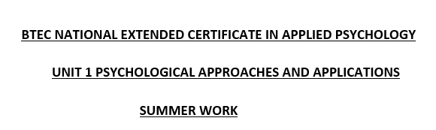

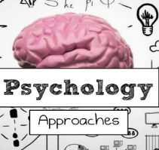
2023

NAME:

This work is for Unit 1 Psychological Approaches and Applications, where we explore four key approaches in psychology – cognitive, learning, social and biological – and apply these approaches to issues relevant to contemporary society.

Below are a number of key studies linked to concepts within each of the different approaches.
Watch the YouTube video by clicking on the links and complete the PMI tables. This is where you will write the following information about the study;
- Plus – anything that you found good or positive
- Minus – anything that you thought was negative or you had an issue with, such as you did not agree with it
- Interesting – anything that you found interesting and may not have considered before.
When completing a PMI table, there are no right or wrong answers. They are your thoughts and ideas and are perfectly acceptable if you can justify them.
Underneath each is a ‘simplepsychology’ link for additional reading of how the study was carried out and its findings. This will be useful for when we study Unit 2 Conducting Psychological Research.
This work will need to be emailed to Mrs Tosh at p.tosh@tsatrust.org.uk

PSYCHOLOGICAL APPROACHES
COGNITIVE APPROACH: This approach believes human behaviour is the result of how our minds process information from the world around us e.g., perception, memory etc.
Loftus and Palmer (2009) Reconstruction of automobile destruction - This was a study carried out to test whether the way a question is worded would affect recall of the circumstances of a car crash. The hypothesise was that the language used in eye witness testimony could alter memory.

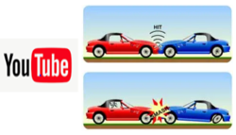
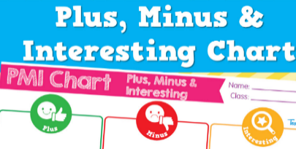
Watch the Youtube video and complete a PMI sheet

https://www.youtube.com/watch?v=-hha1bAtV5c

PLUS | MINUS | INTERESTING
https://www.simplypsychology.org/loftus-palmer.html

SOCIAL APPROACH: This approach assumes human behaviour is influenced by the people around us, our culture and society we live in.
Asch (1951) Effect of group pressure on the modification and distortion of judgement - This study investigated the extent to which social pressure from a majority group could affect a person to conform.

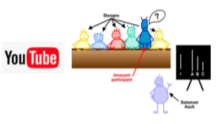
Watch the Youtube video and complete a PMI sheet

https://www.youtube.com/watch?v=NyDDyT1lDhA

https://www.simplypsychology.org/asch-conformity.html

PLUS | MINUS | INTERESTING

BIOLOGICAL APPROACH: This approach believes human behaviour is influenced by biology (e.g., genetics, neuroanatomy, neurochemistry etc) and evolution.
Harlow (1868) Phineas Gage - This case study investigated the effect of traumatic brain injury to the brains left frontal lobe.

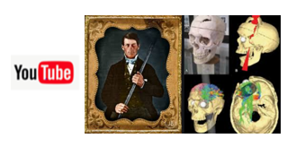
Watch the Youtube video and complete a PMI sheet

https://www.youtube.com/watch?v=yXbAMHzYGJ0

https://www.simplypsychology.org/phineas-gage

PLUS | MINUS | INTERESTING

