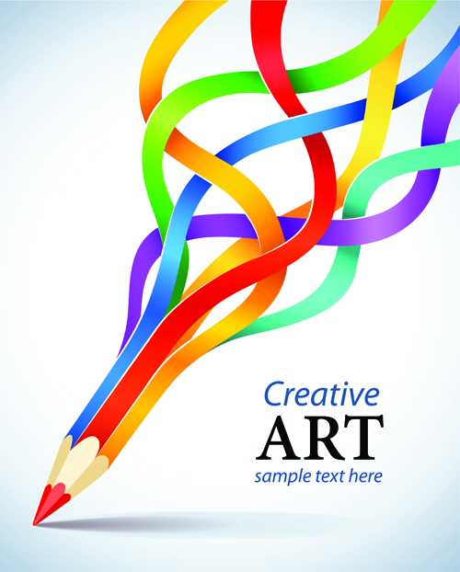

BTEC
Art and Design
2023 – 2024

BTEC Summer Holiday Work

- Research one of the chosen artists from the list below, collect information and images of their work ready to present in your sketchbook in September.

- Create a Mind map with artists, materials and ideas relating to the title “Dreams, Visions and Nightmares”.

- Bring your mind map and artist research to your first Btec Art and Design lesson ready to present in your A3 sketchbook.

