19th November 2024

Dear Parent/Carer

**Sixth Form Reading Day/Sixth Form Open Evening**

**Thursday 28th November 2024**

As part of our students’ progression from Key Stage 4 into Key Stage 5 we will be holding an annual Year 11 into Year 12 Taster Day. This year’s event will be taking place on Thursday 28th November 2024.

As Sixth Form teaching staff will be involved in this event, most Sixth Form students will be granted a reading day at home. Staff will ensure work is available for students to complete on this day, either in hard copy or via Teams. Some departments may still require some students to attend, this will be confirmed with the students in lesson.

We are also holding our Sixth Form Open Evening on the same day, from 3.40pm for future Sixth Form students to visit the Academy and get an idea of what they could be studying with us.

To assist us in the smooth running of the event, some Sixth Form students will be asked to help in a variety of roles. Our students are our best ambassadors; visitors compliment them on their smartness, confidence and the pride they show in their Academy and we want them to be at the forefront of this important event.

If your young person is selected to support with this event, a separate letter with further details will be provided.

Thank you, as always, for your continued support.

Yours sincerely

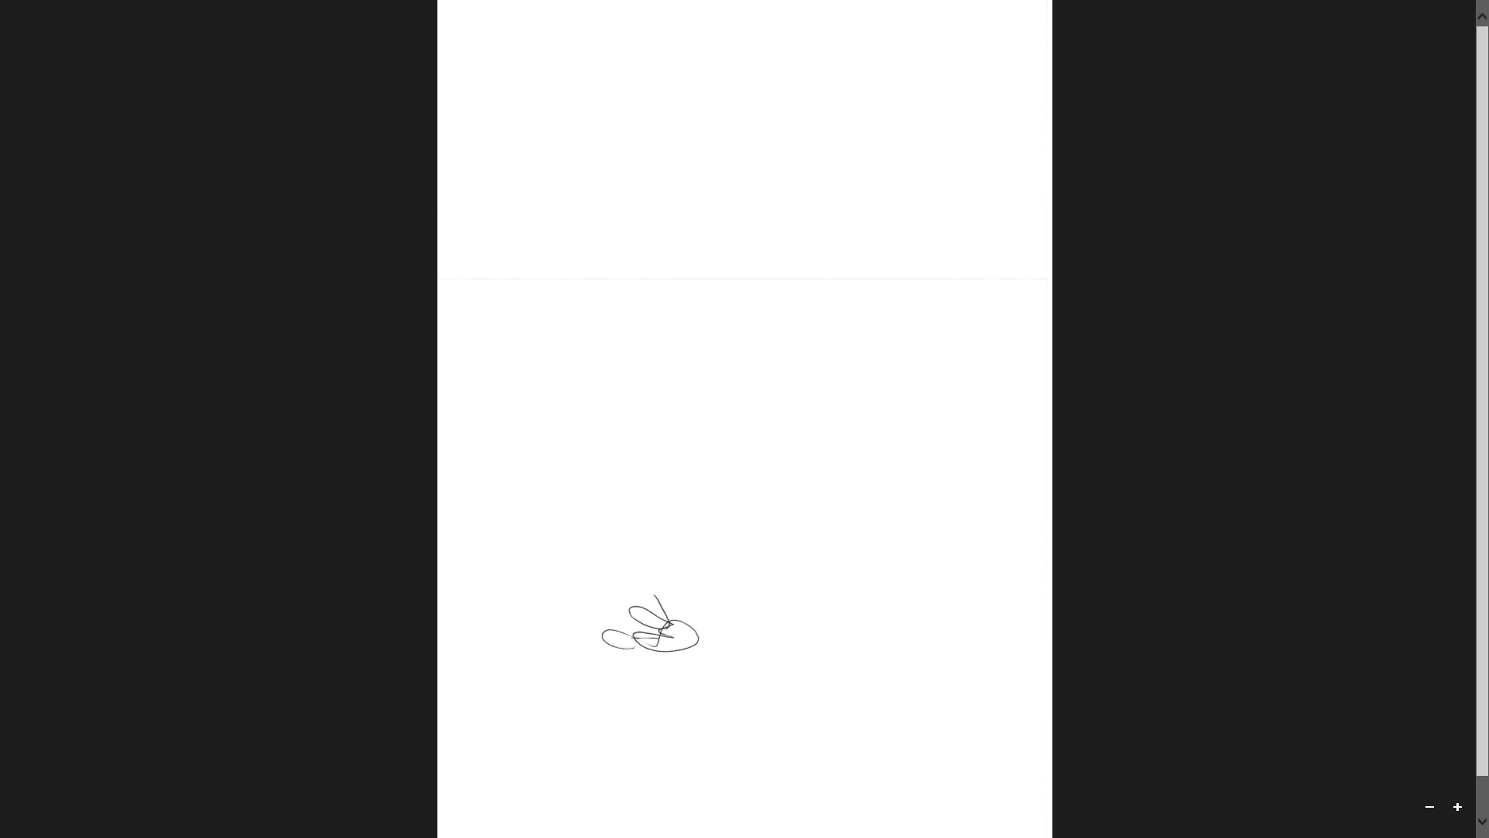

**Mr B Cass**

**Head of Year 12 & 13**